**Building the Millennium Falcon Redux**

**Lean**

Visualizing work - devops boards, tasks, user stories

Burn-up charts

<https://www.youtube.com/watch?v=WfWBxSwqqpU&ab_channel=SoftEd>

Tells us how long will it take the team to finalize the project considering each iteration's result. If its noticeable that the planning was wrong, you can either lower the project scope-remove features, expand with a few iterations, or include new resources-people, to be noted that including new reseources is easier in the start phases rather than at the finish.

Cumulative flow diagram

Shows the stability of the process in time, in different stages

<https://www.youtube.com/watch?v=eo2uv8avEsU&ab_channel=Kanbanize>

Value stream map

<https://www.youtube.com/watch?v=Yto8nUeki-s&ab_channel=IBMTechnology>

<https://www.youtube.com/watch?v=0EORdEvkftA&ab_channel=NigelThurlow>

<https://www.youtube.com/watch?v=MVbZkRjNO4Q&ab_channel=CommunicationforGeeks>

<https://www.youtube.com/watch?v=tGDrt8SV5H4&ab_channel=Plutora>

<https://www.youtube.com/watch?v=C9tfAE7ug8A&t=2228s&ab_channel=MikeJones>

<https://www.youtube.com/watch?v=J7G1pYeCOYU&ab_channel=DevOpsTV>

Control charts

<https://www.youtube.com/watch?v=0CtJJGprG6A&t=6s&ab_channel=JoshuaEmmanuel>

Can be used to measure story points completed by a team in a week/iteration etc, and determine if needed the bottlenecks when and why. 20:22

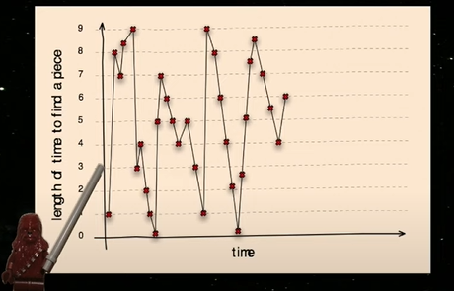

Control chart measuring the time needed to find pieces, it varies alot, from 1 to 9, it is a function of piece size and nr of the same piece type

Solution :

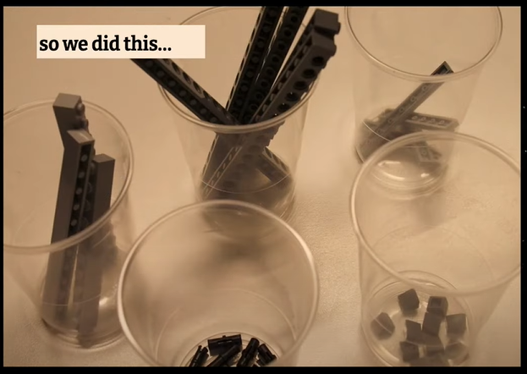

Result :

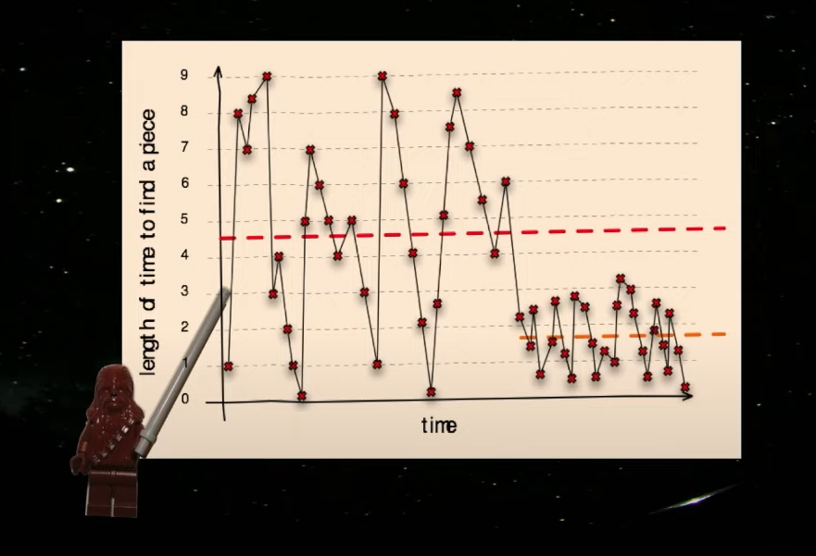

TIPS:

Understand the system you are working on

Visualize your system

Theory of constraints : there will always be a constraint/bottleneck, indentify them and improve

Idenitifying queues in your system can aid in maximizing throughput, once you identify a queue you can determine how deep it is or how fast it might grow and imrpove it. Improving handling queues improves cycle time

Use burnup charts and yesterday's weather to track progress: " Today's weather is 70% yesterday's weather"

Use control charts to identify variability in your process